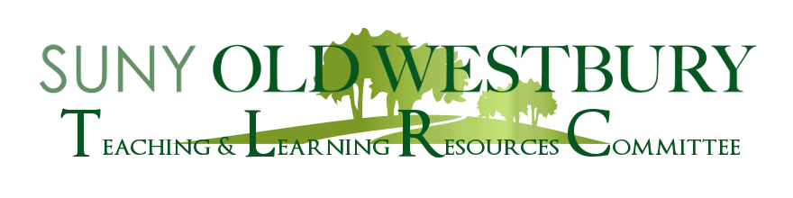

**Open Educational Resources**

**Making your way with Waymaker: Using an Evidence-based Learning Management Platform for Introductory Classes**

A Workshop Led By:

**Kyle Anderson and Mohamed Khalefa**

**Department of Psychology**

**Tuesday, February 7th** **2:40 – 3:40pm** **Virtual (Zoom)**

Drs. Mukherji and Jović will share their experience of using an interactive and dynamic OER platform, Lumen Learning's Waymaker. This platform has been designed using the evidence-based principles of iterative learning and is continuously updated, based on student performance data. Consistent interaction with students and feedback is built into the platform which boosts student engagement, with little extra effort required to maintain it, on the part of the faculty member. This type of platform structure might be helpful for introductory courses across disciplines.

Zoom Registration:  <https://suny-ow-edu.zoom.us/meeting/register/tZwuceuhqTMoGdwmsswkBVCeTWnVdNdzQwMJ>

**Co-Sponsor: Ad hoc OER Faculty Committee**